**Project Document**

**Jenkins installation steps**

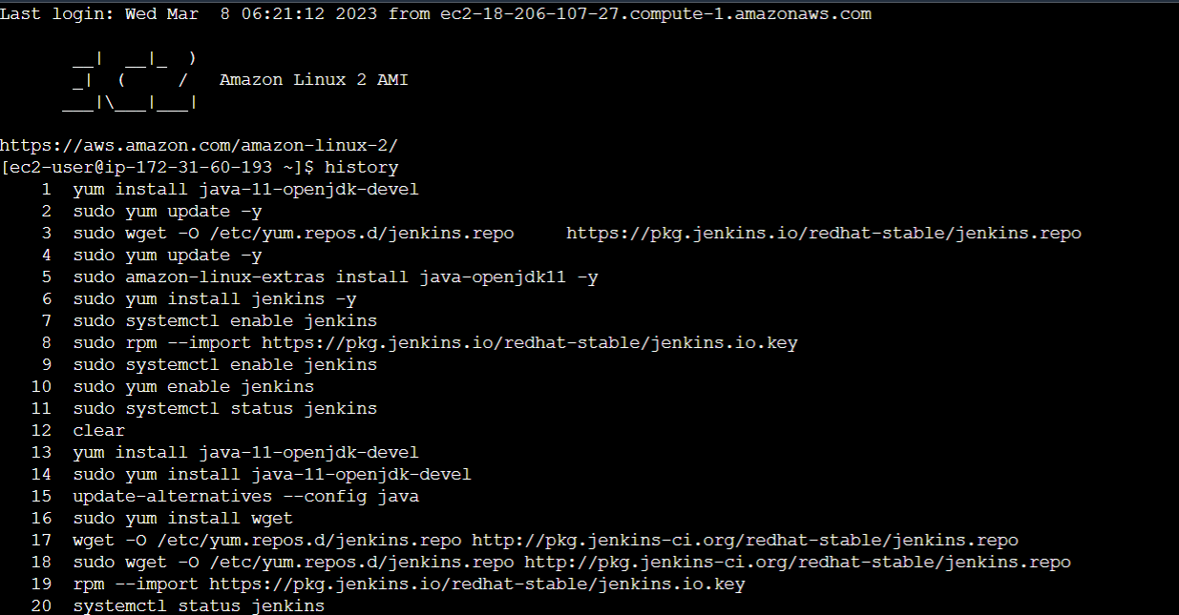

**Jenkins Login page:**

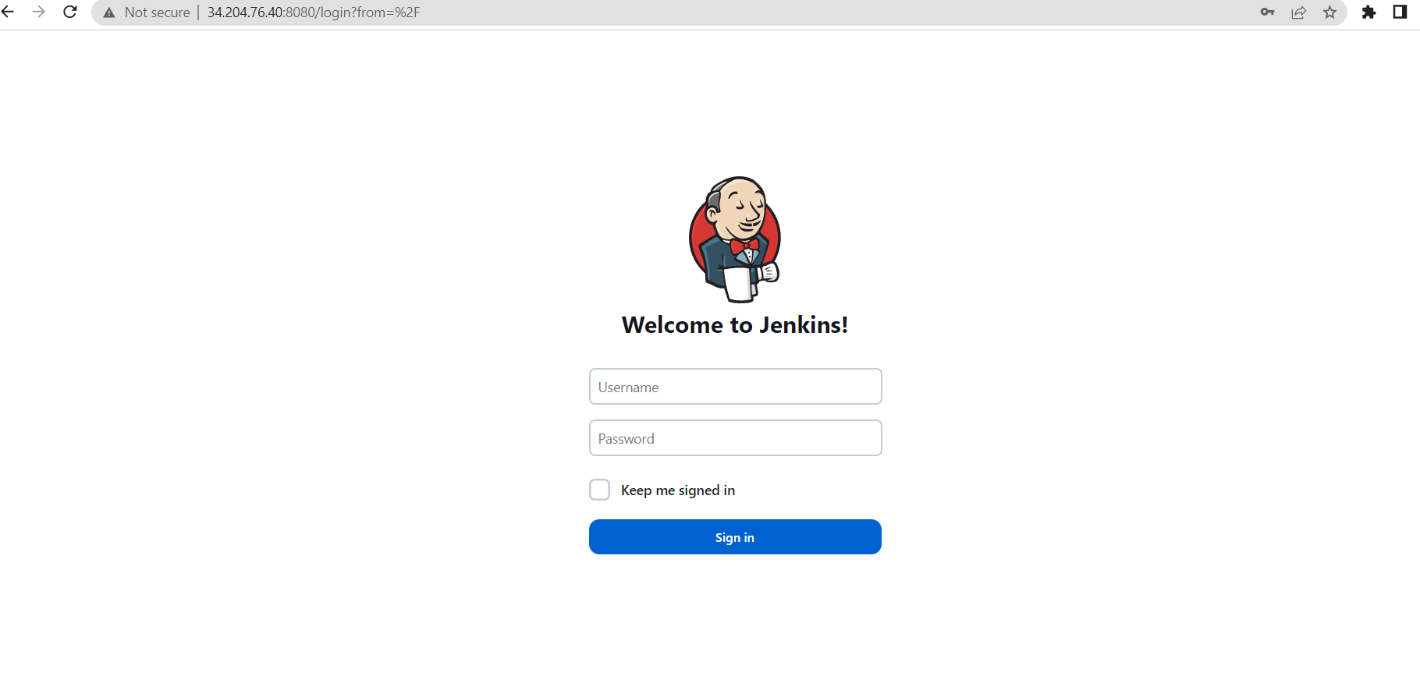

**Github plugins installed**

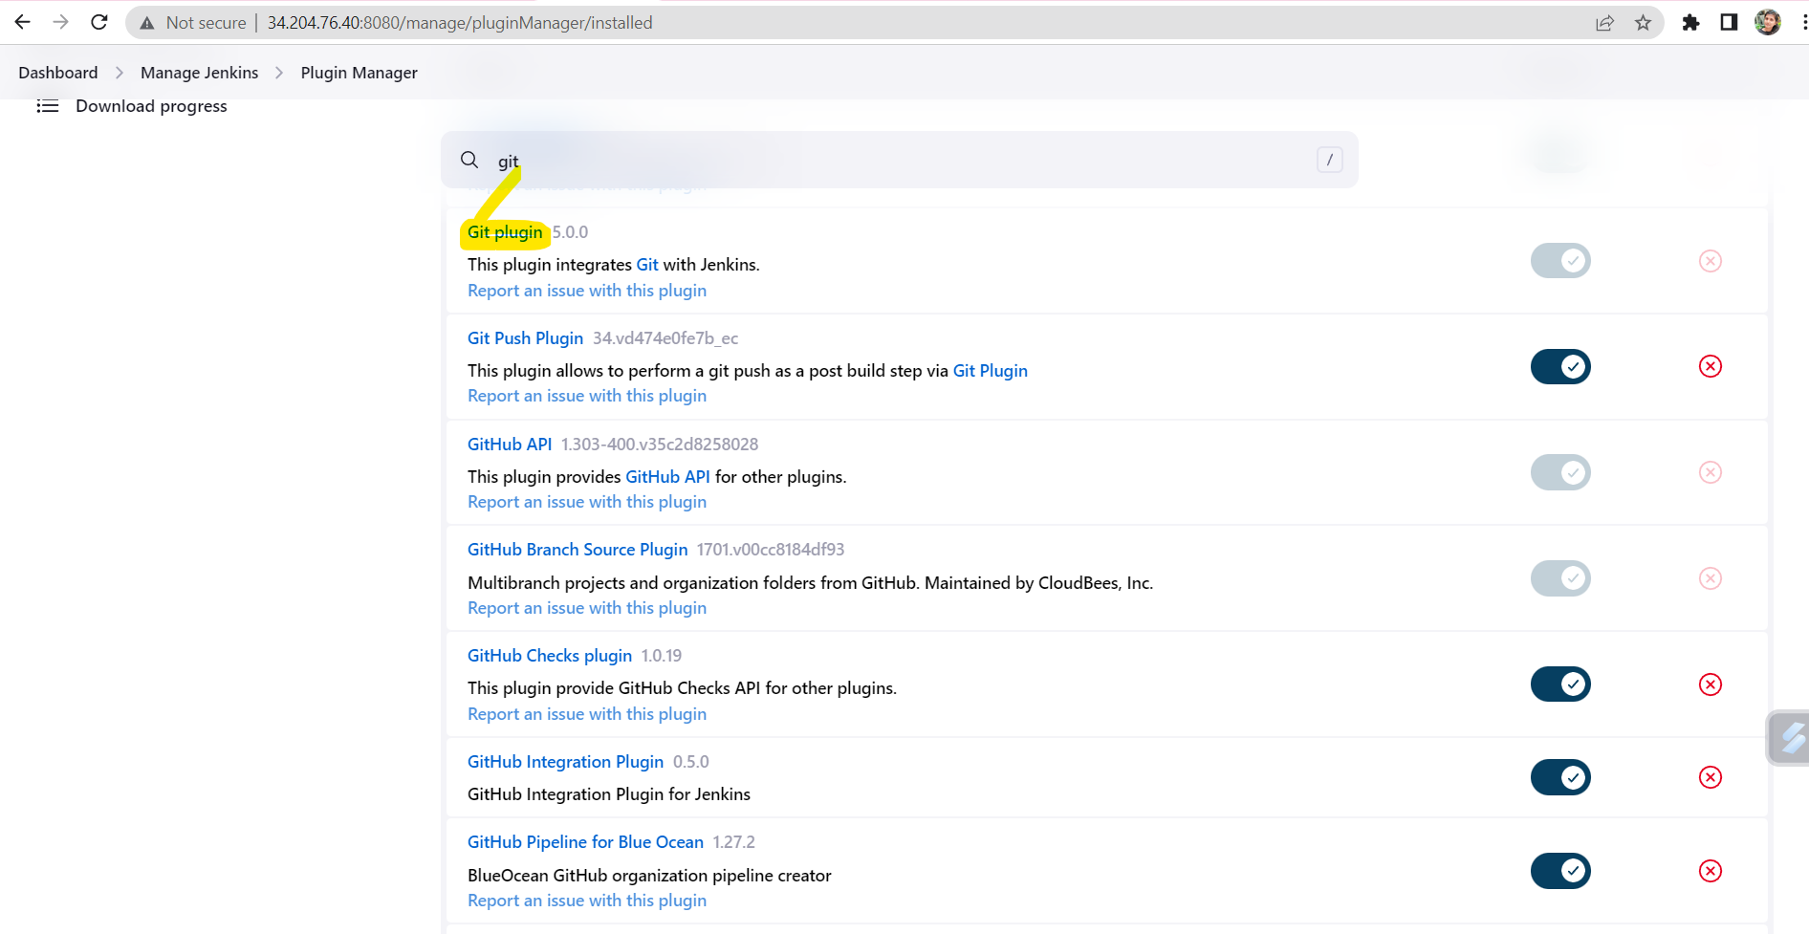

**GitHub config:**

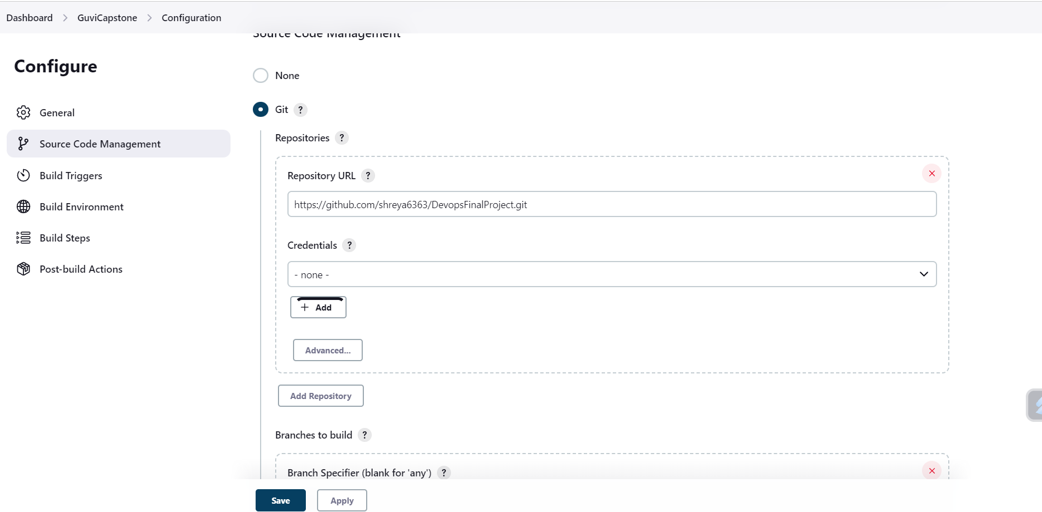

**Docker plugin installed**

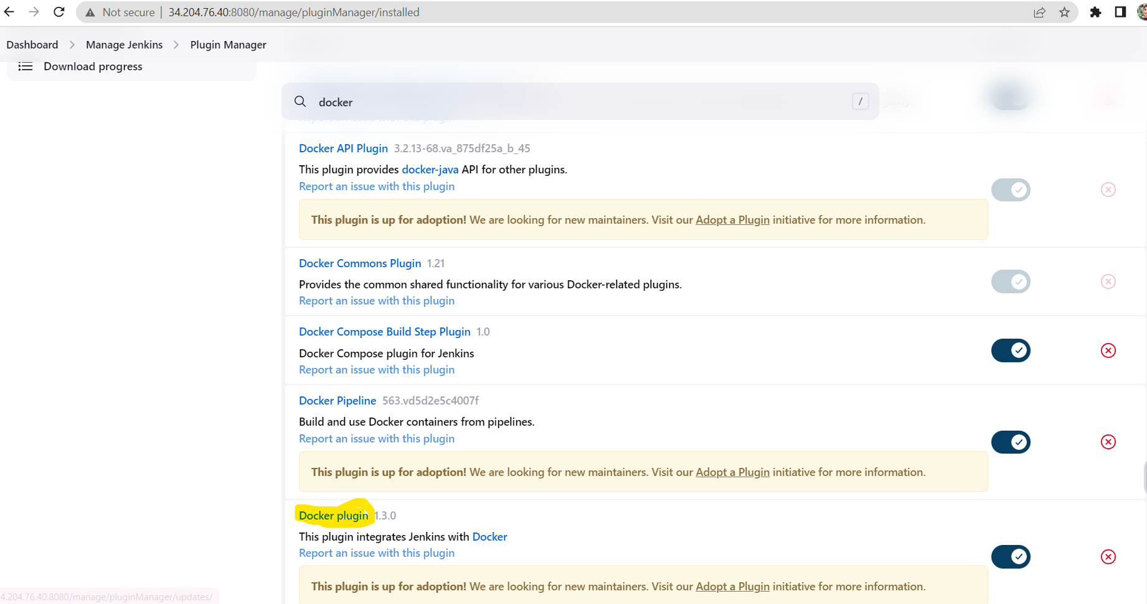

**Build trigger from Jenkins**

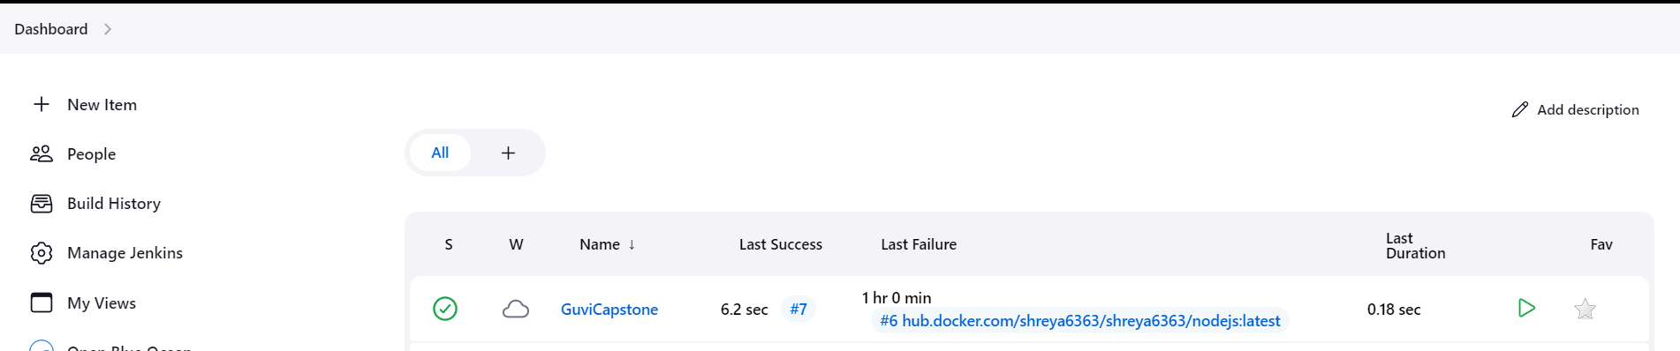

**Docker Hub Repos:**

